Experimenting with Tiger Wraps - Part Two
by Doc Ski and Mike Moroney
In the previous issue of the RodCrafters Journal, which carried a theme of Advanced Threadwork, the first of a two-part interview with Doc Ski (James Labanowski) was provided pertaining to his experimentation with tiger wraps. It covered the basic tiger wrap and burnishing techniques. This is part two of that interview. It covers the use of multiple thread sizes and some very innovative tubes and templates that Doc developed to efficiently design a tiger that employs multi-sized threads. I am sure you will find it insightful and helpful.
Please note that at times in this interview, Doc refers to a particular brand of thread, Bullard, which was acquired by Voodoo Rods. That same thread is now marketed under the Voodoo Rods name and logo. It can be found at https://voodoorods.com.
(Continuation from Part One) …
Doc: The one thing we can say about all threads is that all threads are inconsistent. What I mean by that is size A thread from Fuji is not the same as size A from any of the other manufactures, whether it be Gudebrod, Hitena, ProWrap, Bullard, or any of the other brands. Every manufacturer sets their own standard for what is size A, size B, etc. Diameters vary across different brands and can even vary within the same brand. A one-millimeter difference in thread size might not seem like a big deal but when it comes to tiger wraps, it is. In the same way, colors can vary. If you start wrapping with a color, run out, and move to another spool of the same color in the same brand, it can often be a shade different than what you were working with.
Mike: I have run into that color variation issue with ProWrap. In fact, I now make sure I have a spool with enough thread on it to wrap an entire rod before beginning a new build.
Doc: That happens frequently with ProWrap. Fuji colors are usually close to the same shade, and they are usually consistent in size across spools too. But none of the brands, including Fuji, are perfect.
Mike: Just to be sure I am tracking with you correctly, are you talking about nylon thread or NCP?
Doc: Both. However, the thread size between nylon and NCP are different. That’s because once you put the color preserver in, the thread thickens up. So, NCP size A will be slightly larger than Nylon size A, even in the same brand. The differences are miniscule but again, when we are talking about tigers, miniscule it a big deal. You can change a tiger significantly by just changing thread. However, that can be advantageous. For example, if I am using Fuji size A NCP on the base layer, should I decide that I want to try different size threads on the upper layer, I have found that using Bullard size D and Fuji NCP size D, and sacrificing the Fuji, gives me stellar results almost every time. Occasionally not, but as I said earlier, threads are inconsistent. In thread we have sizes 00, 0, A, B, C, D, E, and EE. Most of what we see now-a-days is A and D. Hitena is the smallest size A. Going from smallest to largest, it is Hitena, then Fuji, then Gudebrod, then Bullard. ProWrap falls into about the same size category as Gudebrod. The same progression is also true for size D. This is not based on empirical data, but more based on my own experience. One advantage of a smaller size A is that you can run a larger A on top of it without finishing it first.
Mike: When you are wrapping a tiger, how do you determine what size or brand of threads you will use?
Doc: What I do now is a base wrap which, most of the time, is three Fuji size A NCP threads. Then I put three coats of finish on it. I have found that I can make the type of tiger wrap I want just by experimenting with different size gaps, or different sacrificial threads, on the upper wrap. I often start my upper wrap with my go-to which is Bullard D. I love that black Bullard D! Then I’ll use Fuji D NCP and run about an inch to an inch-and-a-half on my tiger. That way I can see if it produces the gap size I want. I might think it is close but not really what I want, in which case I will try going down a size and running another inch to inch-and-a-half. So, what is the next thing down from Fuji D NCP? It is Fuji D nylon. As we already discussed, it is slightly smaller. Then, if that is not right but I’m going the right direction (i.e. going smaller is the right direction), I’ll go one smaller. Maybe I’ll go to a B or an A. And if that is too small, then I’ll go one larger. And if that is better, then I will continue to go larger until I arrive at spacing that fits my preference. This can drive some guys crazy. The point is that I do my test wraps over the base wrap until I find the combination that gives me what I want.
Mike: A one to one-and-a half inch wrap is an interesting idea. It would certainly cut down on wasted thread.
Doc: If you do this, and don’t cut the main thread, then yes, you cut down on the amount of waste. A lot of people will wrap their whole layer and then if they aren’t happy with it, they cut it off. That is a lot of wasted thread. By not cutting the main thread, if you’re not happy with the short test wrap, you can wrap another short section with a different thickness thread. I’m still not cutting the main thread. Using the example above, I’m keeping the Bullard size D. That is the main thread in this case. If I’m not happy with the size of the sacrificial thread, in this case the Fuji NCP size D, I will wrap another short section with a different size. When I finally get to where I want, I haven’t lost any of my Bullard D thread. I just wrap it back on the spool. Once I find the gap size that I really want, then I wrap the whole thing. I am not saving the little pieces that I used for test sacrificials, but I’m only wrapping and inch or so, which is not a lot of thread. By doing it this way, the base wrap is protected, and you can do a lot of attempts on the upper wrap to get where you want to be. I can get what I want through experimentation with other thread sizes without costing myself a lot of my favorite thread. This concept is also why I tried to design some visual templates that show me what kind of a wrap I could get with various combinations of thread sizes. I literally have five templates with thirty or forty thread sizes. None of them are exact but they at least give me a starting point in my testing.
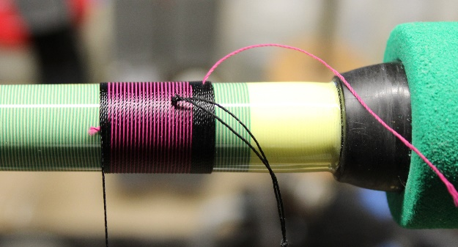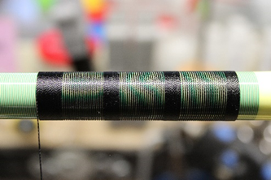
Test Wrapping To Find The Right Gap
Before and After Sacrificing the Pink Thread
Mike: Can you tell me more about those templates and how you use them?
Doc: I would be happy to, but first let me point out that a builder who doesn’t have a huge library of thread might have to stay with the standard tiger wrap – in other words, using the same size threads on top as on the bottom. But for those of us that are thread hoarders, there are so many options it is crazy. You can attain any type of pattern you want by changing the gap size, or the sacrificial thickness, of the upper wrap.
Mike: Thank you, Doc. That is helpful to keep in mind. Perhaps the templates provide a way for those who don’t have a lot of thread to narrow in on what size thread to buy for a tiger?
Doc: To a certain extent they can, but the templates only reduce the amount of experimentation. They don’t eliminate it. Let me explain. Several years ago, I was at an impromptu meeting with a group of guys at a well-known tackle and rod-building shop in Florida. An old timer there handed me some tubes that he said would help figure out tiger wraps. The theory, which was spot-on, was to wrap thread patterns onto clear tubes that can slide over the bottom layer of a tiger wrap to see what various patterns might look like. I decided to build some tubes for my own use and, after some research, decided to build them on Lexan tubes. Lexan is a brand of polycarbonate tubing with pretty good thickness – about an inch interior diameter and about 1-1/8 inch exterior diameter. That was important because a tight wrap wants to squeeze whatever it wraps around. If you use thin tubing, the thread can squash it. So, the tube needed to be thick enough to prevent that from happening. I started wrapping different top wraps (the open layer in a traditional tiger) onto these Lexan tubes. In fact, I made a bunch of samples out of these tubes. Each sample was different and about an inch to 1-1/2 inch long. One time I would use three Fuji A’s and sacrifice one of them. Another time I would use three Fuji A’s and sacrifice two of them. I went through some of the more popular thread companies and made different variations. There are thousands of possible combinations, but I made about forty-eight samples. The tubes are a perfect way to figure out a tiger, but they must be made by the individual. Each builder uses different pressures and tension. So, if I wrap with a lot of tension, the tube will look very different for the person who wraps with very little tension.
Mike: So, you use these tubes as though they are a blank and wrap the upper layer of the tiger on the tube and epoxy it in place?
Doc: Yes, and because it has such a large inside diameter, I can slide it over a blank that has an under wrap for a tiger and figure out the pattern based on a certain thread combination. If I want it to simulate stripes, I keep sliding these tubes on until I find the one that shows the pattern I am looking for. And if I get close but can’t get it exact, at least I have a starting point. Then I go into my testing scenario that I described previously where I start off with the threads that approximate the pattern. If it isn’t quite what I want, then I go to a bit smaller diameter thread. If that makes it worse, then I go a little bit larger in diameter and continue that way until I get it exactly what I want.
Mike: And you’re doing this all with tubes?
Doc: That is correct. Essentially, since I wrapped the tubes and I wrapped the under wrap, it shows me exactly what I need to do. As I mentioned already, an individual might apply a little different pressure than me, or might wrap a little different than me, or maybe burnishes a little different than I do. That is why each individual needs to make their own set of tubes to ensure they are congruent with their wrapping style. I am certainly willing to talk with someone if they want to build their own set of tubes.
Mike: That’s great that you are willing to share your time and expertise to help others this way, Doc. I am curious if you have ever had a situation where the tubes weren’t large enough to slide over the bottom wrap?
Doc: No, but I did have a situation where a guy was building a kid’s rod. He already had the handle on and wanted to put a tiger in the split grip. In that case, of course, the tube diameter wasn’t big enough because the rod already had grips on it. We solved the problem when I went out to the bandsaw and cut a tube in half length-wise. Because the tube was sturdy and was finished, it came out perfect. Then I could lay the half-tube over the rod in the split grip, or anywhere else for that matter.
Mike: That is a great idea! Because the tube is epoxied and cured, that pattern is frozen, and you could just cut the tube in half without damaging its integrity.
Doc: Yes. Now, the longer you wrap rods, the more tubes you can build and not have to start from scratch every time. But I will again stress the point that because we all wrap differently, it is important that a person make their own set of tubes.
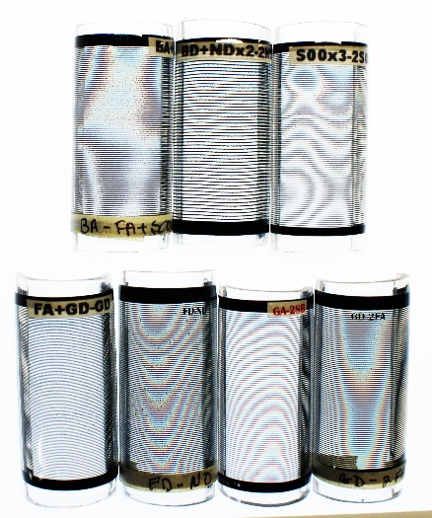
Half Tubes with Varying Thread Combinations
Mike: So, really the only way you can help others with this technique is to talk with them about making their own tubes?
Doc: That is the best way. I can’t make tubes for everybody for the reasons I’ve stated. So, instead I tried to help by coming up with a system that was like the tubes but more flexible, pliable, and easier to use. I wanted something that I could just email to someone. My original idea was to come up with waterslide stickers and essentially duplicate the tube on something that is flexible and pliable. What I ended up doing was taking pictures of three different sections of the tubes on the 0° and 180° axes. I then loaded them into a program in Photoshop. That way I could cut out each thread individually. What I mean is that I would blow each photo up to a large size and take the pen tool and cut out each thread exactly. That allowed me to make a template of that particular tube. However, when I got to experimenting with it later, I found out that the tube and the template weren’t coming out the same. I would put the template and the tube both on a tiger under wrap and would see different results. So, then I put the template on the tube, and it was just maybe only a millimeter different. But that millimeter meant a lot.

Mike: Is that because you were going from a curved surface to a flat surface?
Doc: Yes, from a three-dimensional surface to a two-dimensional surface. I think you know what I am saying. The thread wrap on the flat template was not accurate to the exact sizes. Even though I put it into a program and measured it with a micrometer and got the exact thread size, when you print it and put it on paper, it changes minutely. Never-the-less, it is a good starting point. You still have to do several test wraps to get exactly what you want, but this gets you in the ballpark. I now have more than 40 templates and I can lay them on a base wrap and get close. In other words, I could see that a certain combination of threads over the base layer “can” produce a certain pattern. However, they don’t dial-in precisely like the tubes do. They give you a starting point, whereas the tubes are exact to the thread wrapped on them.
Mike: Are you saying that the reason you made these templates in the first place was so that you could share them with someone else?
Doc: Yes, and I am still willing to share them. But if someone likes and builds a lot of tigers, they would save a lot of time and thread if make their own set of tubes.
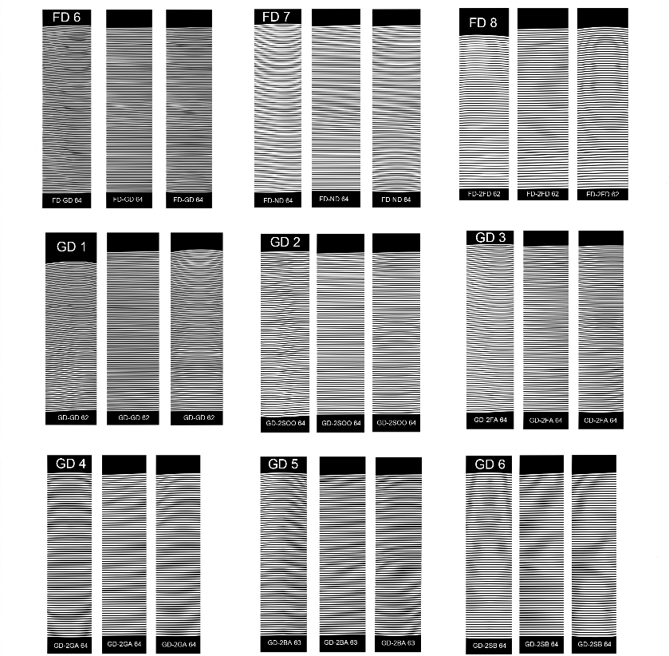
One of Six Templates
Now Available for Download on the CRBG Website
Mike: Back to the tubes for a minute … is the thread on the tubes black or do you have them in colors?
Doc: The tubes are clear with black thread. I suppose someone that is tech-savvy could take my Adobe Illustrated program and change the colors. I like to use black thread and use it in a lot of my tiger wraps. It seems to be easy on the eyes versus a hot color on top. Even a royal blue on top, in some situations, is so hot that it takes away from the pattern. Your eyes focus more on the hot blue than the pattern below it. But some builders want other looks and there are ways to do it with other colors. Sometimes they like that bold look.
Mike: So, the tubes and templates really show you pattern not colors.
Doc: That is basically true.
Mike: Doc, I am sure that you and I could talk for days, and it would stay interesting and enjoyable. You have so much locked up in your brain to share. We have already been talking for several hours, and it is probably time to wrap up this interview. I would like to thank you on behalf of all our readers and myself for sharing these great insights pertaining to tiger wraps.
Doc: It has been my pleasure. At this stage of my career, I am all about helping others. Frankly, it would be impossible to cover everything in this or any other article. There are so many variations, and there are variations within variations. But hopefully this starts a thought process along with some encouragement to experiment.
Mike: Is there anything else you would like to share before we wrap this up?
Doc: I would like to share about a new technique I’ve been developing recently that is producing some stunning tigers. It is quite involved and entails painting the rod beneath the under wrap. But that would require a stand-alone article of its own.
Mike: That sounds interesting. Not to be presumptuous, but if you would like to share that, I am certainly willing to schedule another interview to do so. Would that be of interest to you?
Doc: Sure, that would be great.
At the conclusion of this interview, Doc emailed me the full set of templates, which are now available for download, at no charge, from the CRBG website. Alternatively, if you are interested in building your own set of tubes and would like to get more information about how to make them, you can reach out to Doc at docski377@aol.com. If you are willing to travel to California, Doc told me he is also willing to meet one-on-one or to work on something together. Of course, you would need to schedule a date and time with him.
Lastly, as you likely noticed in the conclusion of this interview, there will be a follow-up interview pertaining specifically to the painting technique that Doc has been developing recently for tiger wraps. Keep an eye out for that in the next issue of the Journal.

